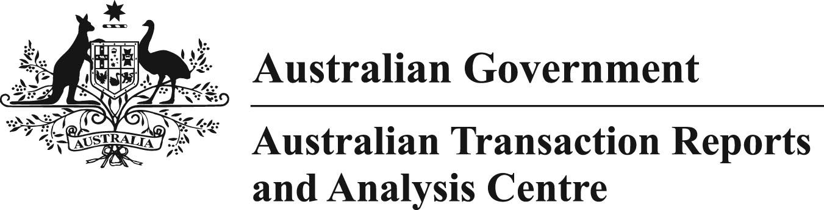

INFRINGEMENT NOTICE

SUBSECTION 184(1) OF THE ANTI-MONEY LAUNDERING AND COUNTER-TERRORISM FINANCING ACT 2006 (AML/CTF ACT)
TO: MoneyGram Payment Systems Inc (ARBN: 127226537)
Suite 402, Level 4
10 -14 Spring Street
SYDNEY NSW 2000
I, Amanda Wood, an authorised officer for the purposes of subsection 184(1) of the Anti-Money Laundering and Counter-Terrorism Financing Act 2006 (Cth) (AML/CTF Act), having reasonable grounds to believe that MoneyGram Payment Systems Inc (MoneyGram) has contravened an infringement notice provision, give this infringement notice (Notice) under subsection 184(1) of the AML/CTF Act.

Details of Alleged Contraventions
It is alleged that MoneyGram contravened paragraph 74(1)(b) of the AML/CTF Act by providing registrable remittance network services as a registered remittance network provider to the 6 persons referred to in Column B of the table in Schedule 1 to this Notice during the period 5 January 2014 to 4 September 2014. These 6 persons (the 6 Unregistered Affiliates) were not registered on the Remittance Sector Register as remittance affiliates of MoneyGram during this period.
The alleged contraventions total 12. The date of each alleged contravention is set out in the table in Schedule 1 to this Notice.
Schedule 1 to this Notice sets out brief details of each of the alleged contraventions.
Schedule 2 to this Notice is an index of the documents referred to in Schedule 1 to this Notice.

Amount of Penalty
The penalty for the alleged contraventions is $122,400. The penalty is calculated in accordance with subsection 186A(1) of the AML/CTF Act and subsection 4AA of the Crimes Act 1914. The penalty is payable to the Chief Executive Officer (CEO) of the Australian Transaction Reports and Analysis Centre (AUSTRAC) (on behalf of the Commonwealth of Australia).

Payment of Penalty
The penalty should be paid by cheque, money order or electronic funds transfer.
If you make payment by cheque or money order, it should be made payable to "Chief Executive Officer of AUSTRAC" and sent to:
CEO, Australian Transaction Reports and Analysis Centre
C/- Enforcement
Zenith Centre, 821 Pacific Highway
Chatswood, Sydney, NSW 2000
Include Reference Number: IA002140
If you make payment by electronic funds transfer, please use the following details:
Name of Bank: Reserve Bank of Australia
Bank Branch: Sydney
BSB: 092 002
Account Number: 111513
Account name: AUSTRAC – Official Administrative Receipts
Reference: IA002140

Statement of effect
If the penalty specified in this Notice is paid to the AUSTRAC CEO, on behalf of the Commonwealth, within 28 days after the Notice is given to MoneyGram, neither criminal nor civil penalty proceedings will be brought in relation to the matters giving rise to the alleged contraventions. Any liability of MoneyGram for the alleged contraventions detailed in this Notice will be discharged.

Date:

Amanda Wood
GENERAL MANAGER, COMPLIANCE

