

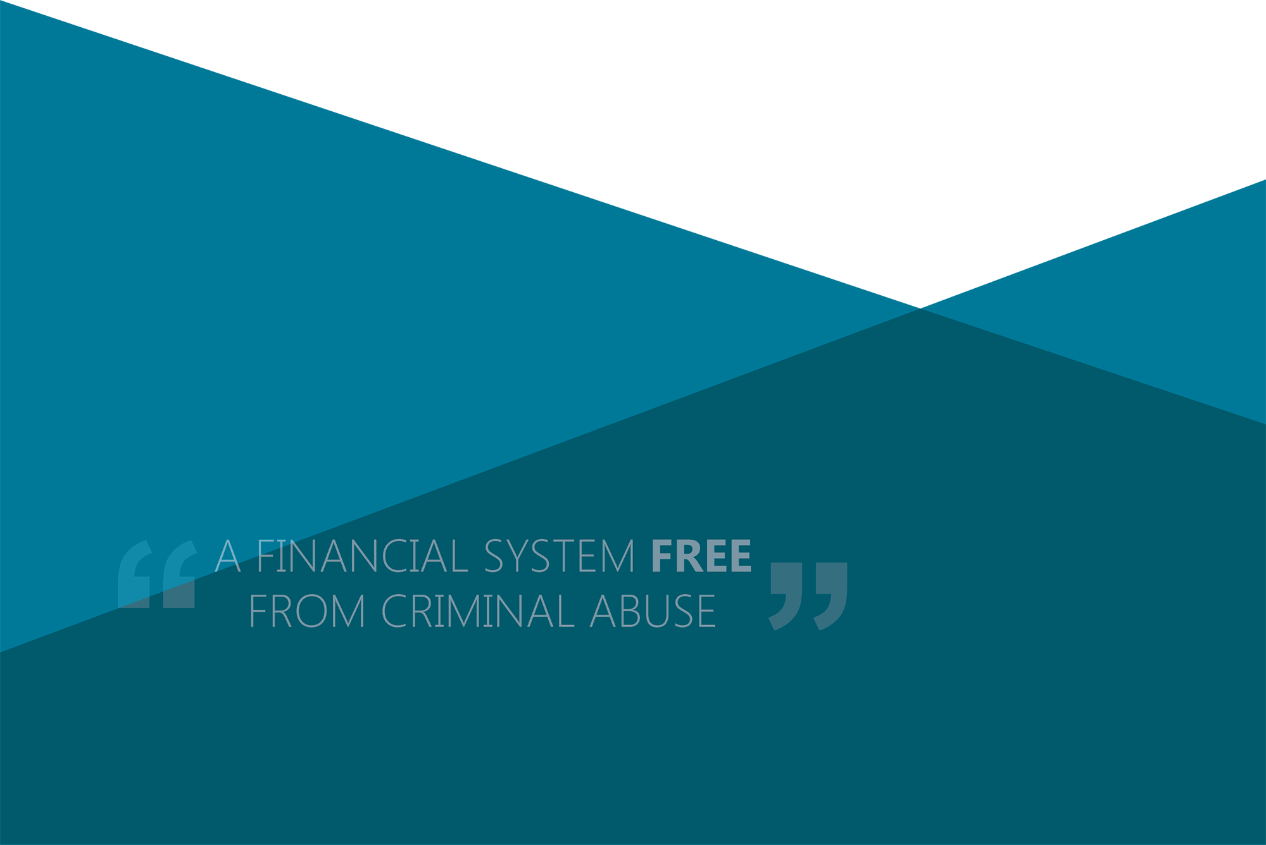

AUSTRAC business profile form

Guide for motor vehicle dealers and solicitors 2024

# Contents

Introduction and overview 2

What must be reported under the FTR Act 1988? 2

The AUSTRAC business profile form 3

**Step 1:** Download the AUSTRAC business profile form 3

**Step 2:** Complete the ‘Business information’ section 4

**Step 3:** Complete/update the ‘Designated services information’ section 12

**Step 4:** Complete/update the ‘Other details’ section 13

**Step 5:** Complete the AUSTRAC Online access section 14

**Step 6:** Complete the Declaration and submit section 15

**Step 7:** Your AUSTRAC Online business account has been created/ updated 16

Further support 17

# Introduction and overview

This guide is for [motor vehicle dealers](https://austrac.gov.au/business/industry-specific-guidance/motor-vehicle-dealers) (in their capacity as insurance intermediaries) and [solicitors](https://austrac.gov.au/business/industry-specific-guidance/solicitors) only. It is a guide to completing and submitting the AUSTRAC business profile form (ABPF).

The ABPF is an online form used to create and maintain an AUSTRAC Online business account. The AUSTRAC Online account provides access to complete and submit transaction reporting forms.

Motor vehicle dealers and solicitors have obligations to make certain reports to AUSTRAC under the *Financial Transaction Reports Act 1988* (FTR Act 1988).

**Note:** If your business provides any other designated services under the *Anti-Money Laundering/Counter-Terrorism Financing Act 2006*, you may have other reporting obligations.Check if you have any other [designated services](https://austrac.gov.au/glossary/d) or [reporting obligations](https://austrac.gov.au/business/how-comply-and-report-guidance-and-resources/reporting).

## What must be reported under the FTR Act 1988?

You must report:

* [suspect transactions](https://austrac.gov.au/glossary/s) - (this applies to motor vehicle dealers); and
* [significant cash transactions](https://austrac.gov.au/glossary/s) – transactions of AUD10,000 or more or the foreign currency equivalent (this applies to both motor vehicle dealers and solicitors)

# The AUSTRAC business profile form

## Download the AUSTRAC business profile form

If your business has not previously reported to AUSTRAC, you need to create an account so that you can submit transaction reports electronically. You do this by downloading and completing an [AUSTRAC business profile form](https://austrac.gov.au/business/new-austrac-start-here/enrol-or-register-austrac).

**Note 1:** The Adobe Reader program (v.8.1 or above) must be set as the default program for handling .pdf files in your chosen internet browser (Google Chrome or Safari are not to be used). This may require updating your browser settings. Please seek independent assistance with any necessary system updates, general searches on related topics, such as ‘display pdf in browser’, may provide helpful step-by-step guidance on how to update your system’s settings.

If your business has previously reported to AUSTRAC, you will already have an [AUSTRAC Online](https://austrac.gov.au/business/your-austrac-online-account) account. You should not create a new account. Instead, see the tip box below.

**Tip:** If your business already has an [AUSTRAC Online](https://online.austrac.gov.au/ao/login.seam) account, you should log in and submit reports directly through your account.

**Forgotten your user name/password?**

**Tip:** Your user name is usually your email address.

**Tip:** If you have forgotten your password, click the ‘I forgot my password’ link on the AUSTRAC Online login zone. Enter your user name on the Reset Password page and click ‘Submit’.

**Tip:** If you still can’t access your account contact the **AUSTRAC Contact Centre** on 1300 021 037 (international +61 2 9950 0055) or [contact@austrac.gov.au](mailto:contact@austrac.gov.au) for assistance.

## **Step 1: My profile**

## Email verification

If you are new to AUSTRAC and you do not have an AUSTRAC Online account, you are required to provide a valid email address and verify it to continue the submission of the form.

The email you provide will be used to email a link upon saving your form for the first time, as a way for you to access the saved draft form. Please note, the link within the email expires **14 days** from when it is first saved. When this link expires, your saved draft form will be permanently deleted, and you will need to start a new form.

If you have previously created an AUSTRAC Online account using your provided email address, you will be guided to logon on to AUSTRAC Online where you can initiate the enrolment of a new business.

## Fields within My profile

### New AUSTRAC Online user

If you are new to AUSTRAC and you do not have an AUSTRAC Online account, provide the following details of the person completing the form. These details will be used to setup your AUSTRAC Online account.

* Given name
* Family name
* Position/title
* Date of birth (optional)
* Telephone number
* Postal address

The Email field will be disabled as it will display the email address you verified.

### Existing AUSTRAC Online user

If you already have an AUSTRAC Online account, the My profile section will not be available in the ABPF forms.

## **Step 2:** Complete the ‘Business profile’ section

Each tab within the ABPF is shown below and these can be used to navigate through the form:

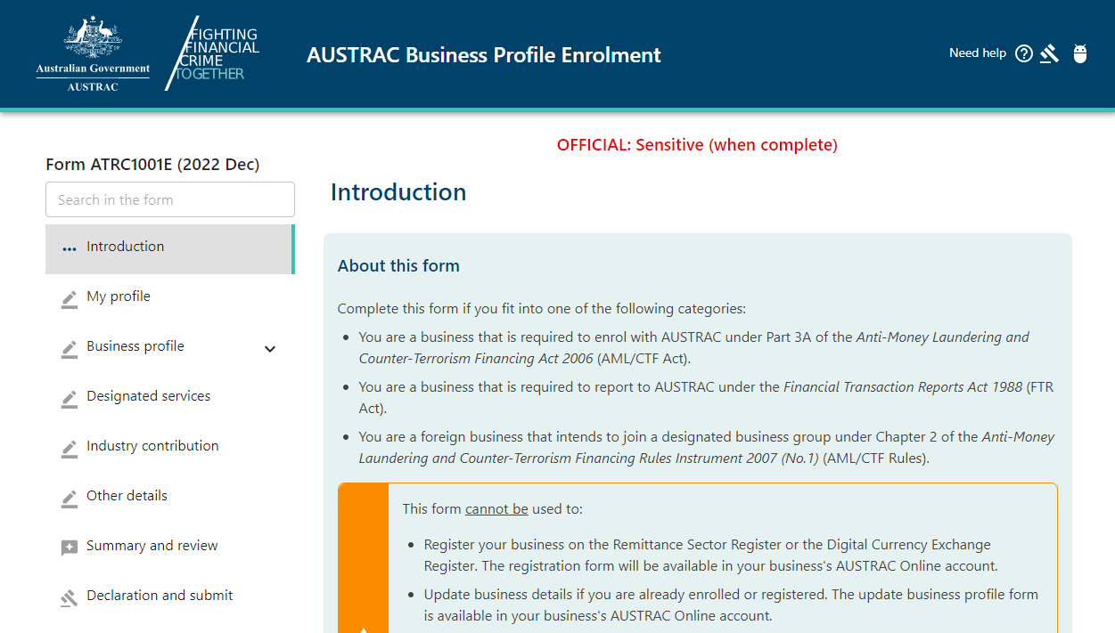

Please note that not all questions within the ABPF will be relevant to your business. The questions that are presented in the form will depend on your answers to previous questions.

### Business information

#### Legal name

Your business’s ‘legal name’ is the name of your business as it appears on all official or legal documents. This name may be different to your business’s trading ‘business name’.

Depending on the structure of your business, the legal name of your business may be one of the following:

* **Sole trader** – your own name
* **Company** – name registered with the Australian Securities and Investments Commission (ASIC) (applies to Australian Private or Public Company) or with the relevant regulator in a foreign country
* **Trust** – name of the trust as shown in the trust document.
* **Partnership** – legal names of all the partners.
* **Association – whether incorporated or unincorporated,** name by which your business is usually known, as stated on any formal documentation (such as a charter or rules)
* **Corporation sole –** name of the office held (for example, the Archbishop of Sydney)
* **Body Politic –** your business’s name as stated on any formal document, or the name registered under the relevant Commonwealth or State Act
* **Other**
  + **Co-operative** – name registered with or incorporated under the relevant state or territory Act; such as the *Co-operatives Act 1992* (NSW).
  + **Superannuation fund** – name registered with the Australian Prudential Regulation Authority
  + **Joint venture** – name that appears on the joint venture agreement
  + **Syndicates** – name of each individual in the syndicate.

#### Structure of the business

The ABPF requires you to identify the structure of your business. To assist you in determining your business structure, a brief description of each business type is provided below:

* **Sole trader** – an individual who is the sole business owner and trades in their own name or under a trading name
* **Company** – an entity incorporated under the *Corporations Act 2001*(Cth) or incorporated under the law of a foreign country
* **Trust** – fund or property held or administered by a trustee for the benefit of others
* **Partnership** – a relationship between two or more persons carrying on a business in common with a view to profit
* **Association** – a group of people acting together within an incorporated or unincorporated association that does not have a view to profit (for example, a sporting club)
* **Corporation sole** – corporation consisting of one natural person holding a particular office and his/her successors to that office (for example, the Archbishop of Sydney)
* **Body politic** – a government of the Commonwealth, a State or Territory, or an unincorporated agency that forms part of such a government, or government body incorporated under the law of a Commonwealth, State or Territory for a public purpose.
* **Other**
  + **Co-operative** – an organisation owned, controlled and used by its members and incorporated under the relevant state or territory Act such as the *Co-operatives Act 1992* (NSW)
  + **Superannuation fund** – a fund that is a provident, benefit, superannuation or retirement fund or public sector superannuation fund
  + **Joint venture** –an association of persons for particular trading, mining or other financial activities with a view to mutual profit.
  + **Syndicate** – agroup of persons working together for a common purpose.

#### Name and address of trustee or partners

If you are a partnership or trust you are required to answer this section. All other business types will automatically progress to the **Business contact details section.**

Partnerships

Provide the name and address of the partners:

* **Individual** – if a partner is a natural person, provide contact details for the partners.
* **Company** – if a partner is a company registered in Australia or overseas, provide the following details:
  + Legal name – for an Australian company this is the name registered with the Australian Securities and Investments Commission (ASIC) or, for a foreign company, the name registered with the relevant foreign regulator.
  + Address – is the principal place of business. The company’s principal place of business is the main place where the company conducts its business, makes decisions or maintains its books and records. It must be a physical address and cannot be a post office box.
  + Business registration numbers – provide details of all registration numbers that apply to the company:
    - **ACN** (Australian Company Number) – nine-digit number allocated by Australian Securities and Investments Commission when an entity registers under the *Corporations Act 2001* (Cth)
    - **ABN** (Australian Business Number) – 11-digit number allocated by the Australian Taxation Office when a business registers with the Australian Business Register
    - **ARBN** (Australian Registered Body Number) – nine-digit number allocated by Australian Securities and Investments Commission when an entity that is not a corporation (for example, a foreign company) is registered
    - **AFSL** (Australian Financial Services Licence) – six-digit number issued by the Australian Securities and Investment Commission when an AFSL is granted
    - **ACLN** (Australian Credit Licence Number) – six-digit number provided by the Australian Securities and Investments Commission when an entity is registered as a credit provider
    - **Numbers associated with a foreign company:** For a foreign company the foreign equivalent of the ACN, ABN, ARBN, AFSL or Australian credit licence number, and the country in which the business number was issued.
* **Trust** – if a partner is a trust registered in Australia or overseas, provide the following details:
  + Name of the trustee and the trust
  + **Individual** – if a trustee is a person, provide contact details for that trustee.
  + **Company** – if a trustee is a company registered in Australia provide the Australian company this is the name registered with the Australian Securities and Investments Commission (ASIC) or, for a foreign company, the name registered with the relevant foreign regulator.
  + **Address** – is the principal place of business. The company’s principal place of business is the main place where the company conducts its business, makes decisions or maintains its books and records. It must be a physical address and cannot be a post office box.
  + **Business registration numbers** – provide details of all registration numbers that apply to the trustee:
    - **ACN** (Australian Company Number) – nine-digit number allocated by Australian Securities and Investments Commission when an entity registers under the *Corporations Act 2001* (Cth)
    - **ABN** (Australian Business Number) – 11-digit number allocated by the Australian Taxation Office when a business registers with the Australian Business Register
    - **ARBN** (Australian Registered Body Number) – nine-digit number allocated by Australian Securities and Investments Commission when an entity that is not a corporation (for example, a foreign company) is registered
    - **AFSL** (Australian Financial Services Licence) – six-digit number issued by the Australian Securities and Investment Commission when an AFSL is granted
    - **ACLN** (Australian Credit Licence Number) – six-digit number provided by the Australian Securities and Investments Commission when an entity is registered as a credit provider
    - **Numbers associated with a foreign company:** For a foreign company the foreign equivalent of the ACN, ABN, ARBN, AFSL or Australian credit licence number, and the country in which the business number was issued.

#### Trusts

Provide the name and address of the trustee and the trust:

* **Individual** – if a trustee is a natural person, provide contact details for that trustee.
* **Company** – if a trustee is a company registered in Australia or overseas, provide the following details:
  + Legal name – for an Australian company this is the name registered with the Australian Securities and Investments Commission (ASIC) or, for a foreign company, the name registered with the relevant foreign regulator.
  + Address – is the principal place of business. The company’s principal place of business is the main place where the company conducts its business, makes decisions or maintains its books and records. It must be a physical address and cannot be a post office box.
  + Business registration numbers – provide details of all registration numbers that apply to the company:
    - **ACN** (Australian Company Number) – nine-digit number allocated by the Australian Securities and Investments Commission when an entity registers under the *Corporations Act 2001* (Cth)
    - **ABN** (Australian Business Number) – 11-digit number allocated by the Australian Taxation Office when a business registers with the Australian Business Register
    - **ARBN** (Australian Registered Body Number) – nine-digit number allocated by Australian Securities and Investments Commission when an entity that is not a corporation (for example, a foreign company) is registered
    - **AFSL** (Australian Financial Services Licence) – six-digit number issued by the Australian Securities and Investment Commission when an AFSL is granted
    - **ACLN** (Australian Credit Licence Number) – six-digit number provided by the Australian Securities and Investments Commission when an entity is registered as a credit provider
    - **Numbers associated with a foreign company**: For a foreign company the foreign equivalent of the ACN, ABN, ARBN, AFSL or Australian credit licence number, and the country in which the business number was issued.

#### Registration numbers associated with the business

Provide details of all registration numbers associated with the business issued by a national, state or territory regulator.

**ACN** (Australian Company Number) – nine-digit number allocated by the Australian Securities and Investments Commission when an entity registers under the *Corporations Act 2001* (Cth)

**ABN** (Australian Business Number) – 11-digit number allocated by the Australian Taxation Office when a business registers with the Australian Business Register

**ARBN** (Australian Registered Body Number) – the nine-digit number allocated by Australian Securities and Investments Commission when an entity that is not a corporation (for example, a foreign company) is registered

**AFSL** (Australian Financial Services Licence) – six-digit number issued by the Australian Securities and Investment Commission when an AFSL is granted

**ACLN** (Australian Credit Licence Number) – six-digit number provided by the Australian Securities and Investments Commission when an entity is registered as a credit provider

**Numbers associated with a foreign company**: For a foreign company the foreign equivalent of the ACN, ABN, ARBN, AFSL or Australian credit licence number, and the country in which the business number was issued.

#### Permanent establishment in Australia or foreign country

A ‘permanent establishment’ is a place at or through which you carry on a business in Australia or a foreign country.

##### It operates through a permanent establishment in Australia

* You have a permanent establishment in Australia if you carry on your business at or through:
* a physical address such as a shopfront, business premises, house or flat; or
* a mobile service such as a car or truck; or
* while travelling within Australia; and
* your business is physically present in Australia.

You have a permanent establishment in Australia if you carry on your business through an agent that is physically present in Australia.

##### It is a resident of Australia and operates through a permanent establishment in a foreign country

Your business is a resident of Australia if:

* **Sole trader** – you ordinarily reside in Australia
* **Company** – your business is incorporated in Australia or your ‘business resident’ in Australia passes the ‘control test’ in relation to the company.
  + To pass the control test in relation to a company:
    - the aggregate of the individual’s (and, if applicable, the individual’s associates’) direct voting interest must be 50 per cent or more; or
    - the aggregate of the individual’s (and, if applicable, the associates’) direct control interests must be 15 per cent or more’ or
    - the company must be sufficiently influenced by the individual (or an associate of the individual); or
    - the individual (either alone or together with associates) must be in a position to exercise control over the company.
* **Trust** – a trustee of the trust is a resident of Australia or an individual resident in Australia who passes the control test in relation to the trust, or a person who benefits or is capable of benefiting under the trust is a resident of Australia.
  + To pass the ‘control test’ in relation to a trust:
    - the individual must be the trustee, or part of a group able to remove the trustee or vary the trust deed
    - the individual must have 50 per cent or more beneficial interest in the trust income, or the individual is part of a group that can control the trust income or the trustee.
* **Partnership** – a partner is a resident of Australia.
* **Corporation sole** – if the corporation sole was established in Australia.
* You operate at or through a permanent establishment in a foreign country if you:
  + have physical offices or business premises in that country;
  + carry on your business in that country;
  + carry on your business in that country through an agent; or
  + provide a mobile service or travel in that country.

##### It is a subsidiary of a company that is a resident of Australia and operates through a permanent establishment in a foreign country

This question applies to a company that operates or is incorporated in a foreign country and whose parent or holding company is registered in Australia.

A parent or holding company is a company that controls your company through ownership of 50 per cent or more of the voting stock. For example, if Company F incorporated in Mexico is 60 per cent owned by American Company C, which is 100 per cent owned by an Australian registered company, then Company F is a subsidiary of an Australian company.

##### Subsidiaries of an Australian company

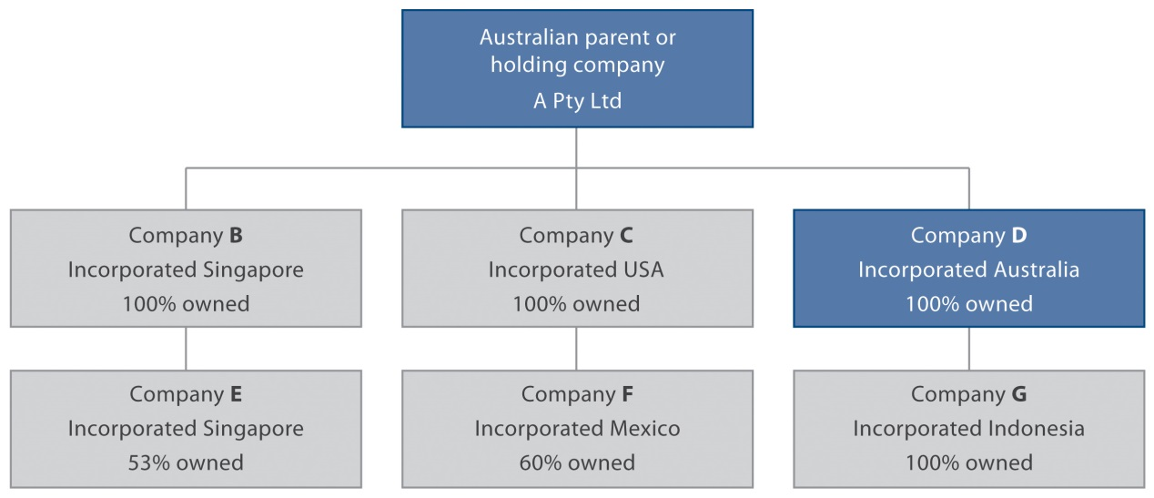

#### Does the business employ less than five people?

Your business employs less than five people if you:

* are a sole proprietor or partnership without employees; or
* employ four people or less, regardless of whether the employees are full-time, part-time or casual.

An employee is a person that works under a contract of employment with your business or a person that your business pays wages or a salary to.

#### Business name

If your business trades under a business name that is not the legal name of the business, you must provide the following details.

* Business name – this is the business name registered with ABR or the name by which your suppliers and customers know you.

#### Business details

##### Physical location / business address

Your business’s physical location / business address is the main place where you conduct your business. It must be a physical street address and cannot be a post office box.

##### Postal address

Your business’s postal address can be the business’s principal or registered place of business or a post office box.

##### Registered office of the business

This question only applies to your business if it is a company. Your registered office address is as registered with ASIC. AUSTRAC will send notices or correspondence to this address. AUSTRAC may also send emails to your nominated email address or correspondence to your postal address.

Your registered office does not need to be your principal place of business. For example your registered office may be with a legal practitioner or accountancy firm.

If you are a registered or unregistered foreign company and have appointed a registered agent you must provide their details here. If you are an unregistered foreign company and do not have a registered office you must provide the full address of the company as registered by the relevant foreign registration body.

##### Contact details for principal place of business

You must provide contact details for your physical location / business address including telephone number, fax number and email address if applicable.

##### Website

If your business has a website, provide the website address.

#### Primary purpose of business

The primary purpose of your business is your core business activity relating to the designated services provided.

* If you are a motor vehicle dealer select ‘Retail and consumer products’; then select ‘motor vehicle dealer’
* If you are a solicitor select ‘Other’; then select ‘Solicitor or other legal service’

## **Step 3:** Complete the ‘Designated services information’ section

Click on the Designated services tab. You will be presented with the following page and sub-tabs (Digital Currency Exchange service, Remittance Services, Compliance officer, and Financial, Gambling, Bullion Services):

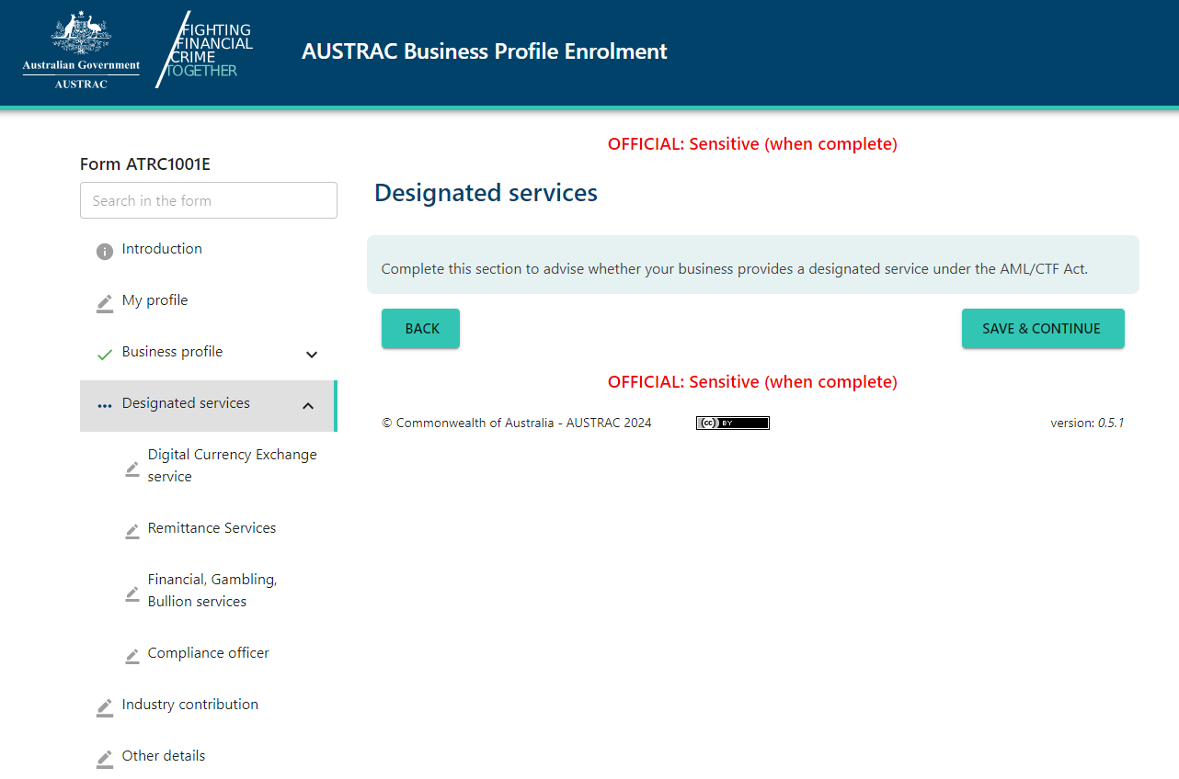

Please note that the sections that are presented in the designated services section will depend on your answers to previous questions/sections.

Answer **No** to each of the Digital Currency Exchange service, Remittance Services, and Financial, Gambling, Bullion Services sub-tabsif you don’t offer these services. If you do offer any of these services you will need to be enrolled, may be required to register, and will be presented with different questions on this form. Check to see if you offer these, or other, [designated services](https://austrac.gov.au/glossary/d).

Once you have completed all relevant sections of the page, click ‘Save & Continue’.

If you answered No to the three sub-tabs in the Designated services information section, the following three sections of the ABPF – **Remittance registration information; Digital Currency registration information;** and **Industry contribution information** – will present the following message:



Proceed to the **Other details** section of the ABPF.

## **Step 4:** Complete/update the ‘Other details’ section

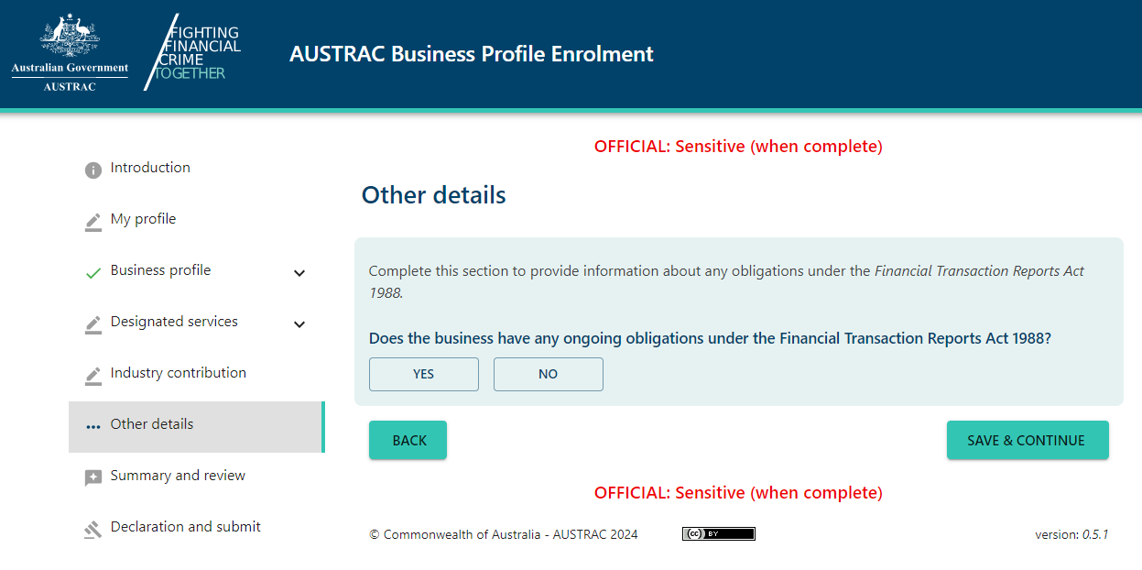

* Click on the **Other details** tab
* If applicable, Select **Yes** to the question ‘Does your business have any ongoing obligations under the Financial Transaction Reports Act?’
* This will reveal further fields for completing the details of the primary contact for communicating with AUSTRAC. This information is mandatory and the primary contact becomes the person who receives the account details and log in details for making reports.
* You must use a unique (new) email address for the primary contact, i.e. one that has not been used in any previous ABPF submission to create an AUSTRAC Online business account.
* Once completed, click **‘Save & Continue’**

**Note:** Motor vehicle dealers and solicitors must answer **Yes** to the question ‘Does the business have any ongoing obligations under the [*Financial Transaction Reports Act 1988*](https://www.legislation.gov.au/Details/C2018C00115)*?*

## **Step 5:** Complete the Summary and review section

Review the information you have entered and click **‘Save & Continue’**

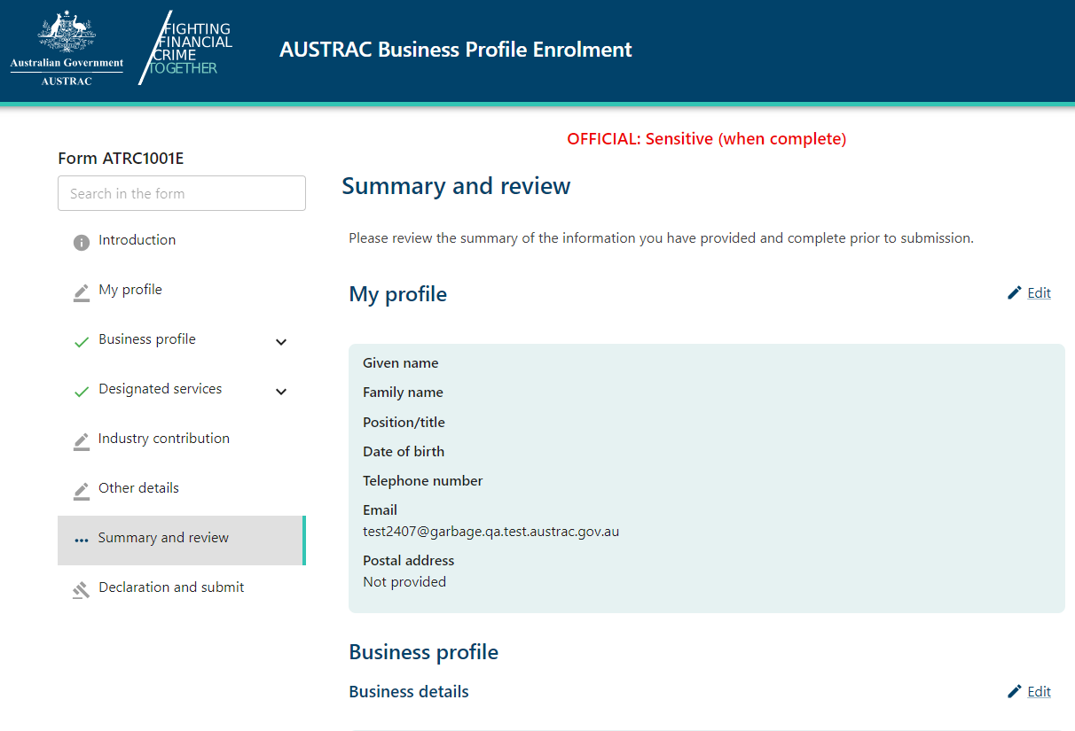

## **Step 6:** Complete the Declaration and submit section

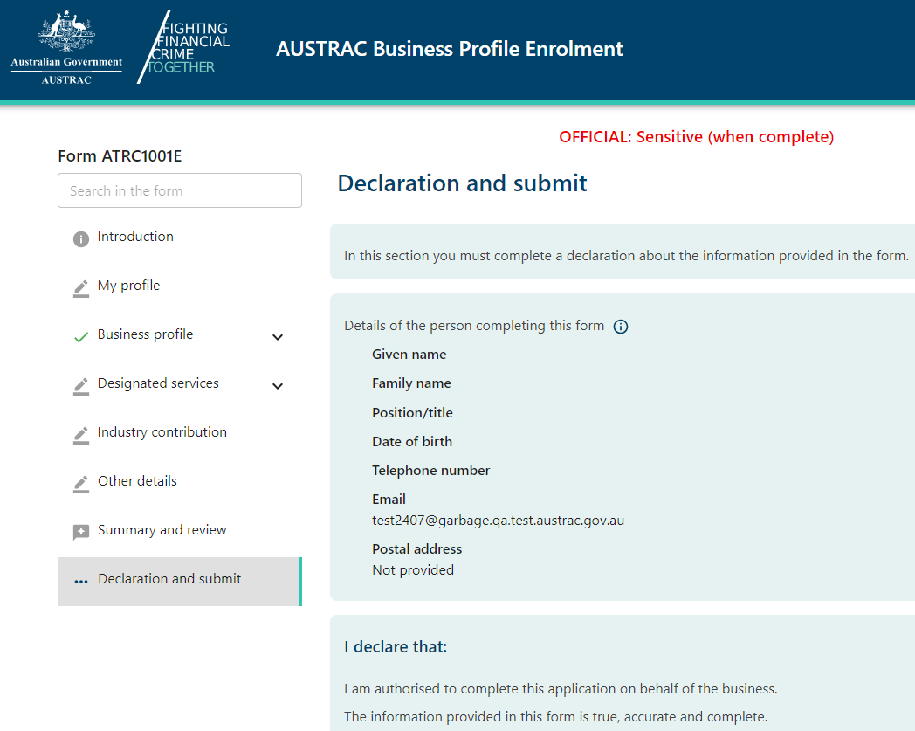

You are required to complete the declaration for creating an AUSTRAC Online business account.

The Declaration for creating an AUSTRAC Online business account requires the person completing the form to declare the following:

* I am authorised to complete this application on behalf of the business.
* The information I have given in this form is true, accurate and complete.
* I understand criminal or civil penalties may apply for giving false or misleading information or for failing to supply information.
* The person making the declaration is the person who launched the application form. This may or may not be the AML/CTF Compliance officer. The following details will be prefilled and *may* be partially editable:
* Given name – provide details the person’s given names, including first name and any middle name or initial
* Family name – this is the person’s surname as it appears on all legal documents (for example, a birth certificate)
* Date of birth – provide the person’s day, month and year of birth (optional)
* Telephone – the contact telephone number for the person during business hours. This may be a mobile phone number.
* Email address – provide the person’s work email address. If the person does not have a work email address, provide their personal email address
* Postal address – the person’s principal place of business or registered place of business, including state or territory and country

Upon completion, click on the **Submit** button.

**Note:** On submitting the ABPF the **Submission Confirmation** page will be presented. This page will provide you the ABPF submission receipt number and the option to download a copy of the receipt.

It is recommended that you record the ABPF submission receipt number for future reference with AUSTRAC if needed.

**Note:** The declarer of the form will receive, by email, a user ID and temporary password soon after submitting the ABPF to enable access to your AUSTRAC Online business account.

Once your AUSTRAC Online business account is created, you will be able to access reporting forms for any transaction reports you seek to make from within your online account.

# Further support

The AUSTRAC Contact Centre can assist you with further information about AUSTRAC Online or your obligations under the AML/CTF Act or FTR Act.

If you need assistance please contact the AUSTRAC Contact Centre by:

* **Phone**: (local call within Australia) 1300 021 037
* **Phone**: (international) +61 2 9950 0055
* **Email**: [contact@austrac.gov.au](mailto:contact@austrac.gov.au)

**National Relay Service (within Australia):** TTY or computer with modem users phone 133 677 and ask for 1300 021 037.

Speak and listen (speech to speech relay) users phone 1300 555 727 and ask for 1300 021 037.